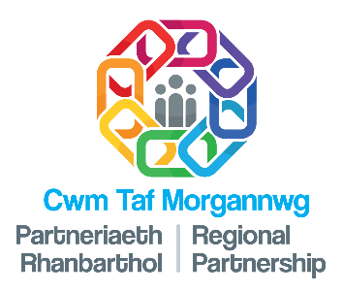

PHOTOGRAPHY/VIDEO CONSENT FORM
Fair processing information
The Cwm Taf Morgannwg Regional Partnership might take photos or videos for publicity. They need your permission first. These images might be used by health boards, local councils, or on social media.
Images and videos can be used for posters, adverts, or websites. They might also be in newspapers or on social media like Facebook or Twitter. Your permission is needed for this.
If you change your mind, you can tell them you don't want your images used anymore. But if they are already online or in print, they might not be able to remove them.
You need to sign a consent form to give your permission. You should get a copy of this form. If you want to stop your images being used, contact Rebecca Goodhand.
You can agree to be photographed or filmed. You can also agree for your child to be photographed or filmed. You need to write your name and date on the form.
You can choose if your images are anonymised or not. This means people might not know it's you in the pictures or videos.
Once images or videos are online or in newspapers, the partnership can't control where they go. They might be shared by others.
Make sure you understand everything before you sign the form. It's important to know how your images might be used.

This form is about giving permission for photos or videos. It is for people who are patients, parents, or part of the community. You can also be a worker from certain groups.

I understand pictures or videos taken today might be used in many places.
They could be on posters, adverts, or websites like Facebook or Twitter. They might also be in newspapers or part of special campaigns.
I understand I can say I don't want my pictures or videos used anymore by writing to the CTM Regional Partnership. But, if they are already shared, it might not be possible to remove them from everywhere.
Signature: | Print name: | Date:

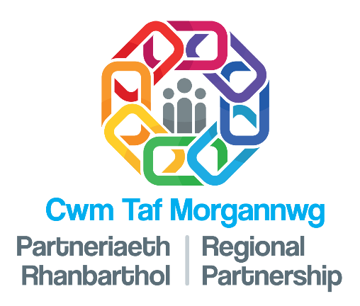

PART 1

CONTENT/ PHOTOGRAPHY/VIDEO CONSENT FORM
Having read and understood the Fair processing information, I give my consent to the use of images or video footage as specified below:
Please Initial
1. | I am a patient/parent or guardian/member of the general community  (delete as appropriate)  OR  I am a member of CTM RP/ CTMUHB/ local authority/ third sector staff and my job title and work base are: |  |  | Initials
2. | I agree to let a story I shared be used. This is for the CTM Regional Partnership to tell others about their work.
3. | I say yes to having my photo taken. This is also for the CTM Regional Partnership to use.
4. | I agree to be filmed. This is for the same reason, to help the CTM Regional Partnership share information.
5. | I agree for my child’s photo to be taken. This is also for the CTM Regional Partnership.  Name of child:
6. | I agree for my child to be filmed.  Name of child: DOB:
6. | I give permission for all these things to be used as explained in the rules. This is called fair processing.
7. | I choose/ do not choose for my pictures or videos to have my name.
8. | I understand the CTM Regional Partnership cannot control where they go. They might be used by others.
Signature: |  | Print name: | Date:

