


My Dream Home
Your guide to moving into independent living in Rhondda Cynon Taf, Bridgend or Merthyr Tydfil.



ctmregionalpartnershipboard.co.uk

Contents

- Introduction - what is this booklet about? 1
- This is me - what is important to me? 2
- Timeline 6
- Types of home 8
- My Dream Home 22
- Having conversations 24
- Advocacy 26
- Understanding social services 28
- Arranging a visit 30
- Moving in 33
- Frequently asked questions 34
- Directory 36

*Please note:
Some of the stories in this booklet are fictional. They are based on common experiences and are designed to reflect the types of support that may be possible.

My Dream Home Guide

Introduction 01

What is this booklet about?

This My Dream Home booklet has been created to help you choose where you might want to live in the future, and the types of things you will need to know as you choose your next home.

“My Dream Home” is a name chosen by people with learning disabilities.

It means any home can be special.
A home becomes a dream home when we can choose how it looks and how
it feels. This helps to make a home feel like our own.

This information has been created with people with learning disabilities, parents and carers and professionals who have experience of the process.

We know choosing the right place to live
is an important decision and it can be taken at your own pace. This booklet should help you feel more in control of the choices you are making, so you can live a happy life in your future home.
If you are a parent/carer or someone who knows a person well, you can also use this booklet to help with their future housing choices.

There are spaces to make notes of any questions you might have. There is a directory at the back of the booklet if you do need to contact organisations for more details.

We wish you luck. Happy house hunting!
Rebecca, Mark, Lisa,
Kay, Eleanor, Pauline, Tom, Anne Marie, Keiron, Adam, Joanne, Ceri, Stephen,
Richard, Leigh, Glynis, Claire and Tina

My Dream Home Guide | 1

This is me

Use this page to say what is important to you.
You can fill this out on your own or with support from a parent, carer or somebody who knows you well.

What I like to be called

Who I live with
Where I live now

The important people in my life






My Questions

Write down your questions as you go through this booklet.

2 | My Dream Home Guide









02

Things I am good at The best things about me

Things I like to do in the day Things I like to do in the evening

Things I like to do at the weekend Things that make me happy at home

My Dream Home Guide | 3

02

Things that keep me safe

Things I need help with
Things that keep me healthy

How I like people to talk with me









What makes me sad or scared

Who are the important people in your life?
The important people in your life could be anybody who helps you. This could be your parents, family, carers, friends neighbours, professionals.

4 | My Dream Home Guide




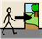
02

Places I like to visit Places I’d like to go

New things I’d like to do

Other things I’d like to share

My Dream Home Guide | 5

Typical Timeline

1 2 3

Fill in This Is Me so people know all about you.
Look at the types of accommodation
options available and think about the type of home you might like.
See page 8-21.
Fill in the
My Dream Home pages to get an idea of what might work for you.
See page 22.

4 5 6a

Speak to family, friends and people you trust.
See page 24.
Get in touch with groups or
organisations who can help you.
See page 36.
Contact social services for an informal chat about home choices.
See page 36.

6b 7

Meet with social services to discuss your home options. This might be a social worker. See page 28.
When you are ready, let social services know you would like to find your new home.









6 | My Dream Home Guide

Where do you start? This booklet can help. 03

8 9 10

Your application for a new home will be looked
at by social services.

Your name is put on a waiting list for a home.

You will be offered a possible home.

11 12 13

You will go on visits to your new home.
See page 30.
A final decision will be made by
everybody involved on your new home.
Move into your new home

Remember:
This timeline is only a guide. You may experience different timescales based on your individual circumstances.
Everyone’s journey is different and you can move at your own pace at every stage.

Who is a Social Worker?
Social Workers are professionals from social services who can offer you an assessment of your needs to discuss what matters to you, and
help you plan where you’d like to live.







Remember to write down your questions and thoughts as you go through this booklet.

My Dream Home Guide | 7

Types of homes

There are different types of homes for different needs.
The type of home you look for will depend upon your assessed needs and what matters to you. Depending on where
you live, each council work with different organisations that provide homes.

What is an assessed need?
This is the assessment that will be carried out by a social worker about what matters to you.
See page 28 for more information.

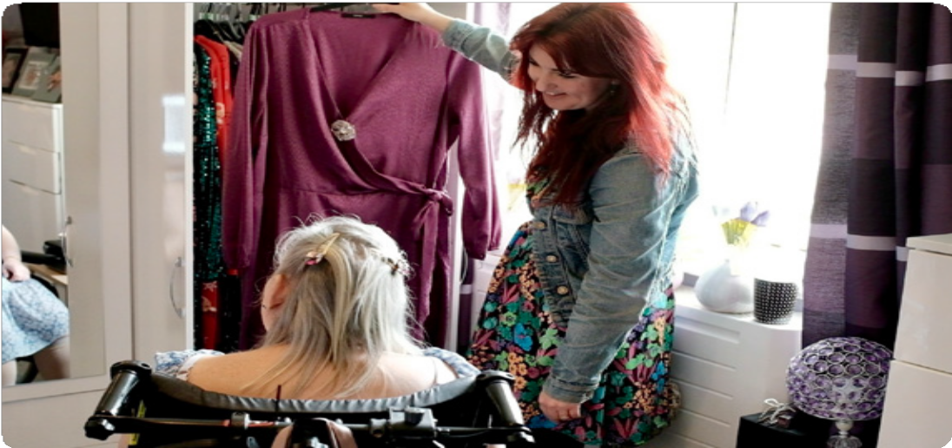

My Questions

8 | My Dream Home Guide

04

Generally, there are five different types of home:

Supported Living Tenancy

You will have your own home, usually with an occupation contract. You will be helped to live as independently
as you possibly can with assistance from care and support staff.

This will involve paying your share of the household bills. You will be able to look after your home by cleaning,
cooking, and making everyday choices to make the home your own!

Depending on what you prefer,
you may have your own flat or share your home with others.
If you choose to share, you will have your own bedroom but share spaces like the kitchen. If your support needs
are more complex, for example you have lots of health needs, supported living could still meet your care and support.

You will have your own home however your support team will have specialist training to meet your needs. This may include 24 hour support if needed.
They will work with people who are close to you and any professionals that can help you live as independently as possible.

What is an Occupation Contract?
An Occupation Contract is the new type of tenancy agreement. You and your landlord both sign the Occupation Contract. This gives you rights as a tenant by law. If you live in supported accommodation, for example, your landlord will be the organisation that manages the property. You will be known as the tenant. The agreement includes rules you both agree to.

What is care and support?
Everybody’s care and support will be different, but could be the type of things you need help with to live independently, such as healthcare, finances, or cooking.

My Dream Home Guide | 9

04 Chloe’s story

Hi, I’m Chloe. I’ve been living independently for five years, and I absolutely love it.

Having my own home gives me freedom, confidence, and a real sense of pride. It’s something I’ve worked hard for, and I’m proud of how far I’ve come.

I’ve always enjoyed helping others, and I’ve volunteered with charities like Follow Your Dreams and Cwm Taf People First for many years. These roles have helped me grow and connect with my community.
I’m also the Chair of the Cwm Taf Morgannwg Regional Partnership Learning Disabilities Group. In this role, I support people with learning disabilities to speak up and be involved in decisions that affect their lives.

Living independently has changed my life, and I hope my story can inspire others.



You can hear more about my story by scanning the QR code below:

10 | My Dream Home Guide

Sam’s story 04

My name is Sam and I have been in supported living for over ten years.

I live with three other people, and my home is close to all my family and friends. I love being able to keep in touch with them and visit on a regular basis. I get on well with the care staff in my home and I have a mobility car which they drive to get me to places.

They also support me to use public transport. I have a very busy life and attend community projects four days
a week. I also have a really good social
life and attend choir, swimming, the Gateway Club and play skittles
every Sunday night in the local club.
I love going on day trips to theme parks and went to Disneyland Paris last year with my sister and her partner.

I love having my own home and my confidence and independence continues to grow.




My Dream Home Guide | 11

04 Types of homes

Shared Lives

In Shared Lives you can move in and live with a Shared Lives carer you are matched with.

This is a care and support service to help you live independently.
You will have your own bedroom, and you will share family spaces like the lounge, kitchen and bathroom.

The family you live with will provide support to help you with independent
living skills, like cooking and cleaning, making friendships and connections. The family will be trained to support you and meet your needs.

You may move in and live with the Shared Lives carer, or you may visit for a short break or even a day.

The Shared Lives scheme is checked by your local council.

My Questions

12 | My Dream Home Guide

Jen’s story 04

I’m Jen, and I’m 53 years old. I used to live with my elderly parents. They wanted to make
sure I’d be safe and happy if they could no longer care for me.

That’s when I met Rachel through the Shared Lives scheme. We bonded over our love of animals and gardening, and I moved into her home 17 years ago.

The transition was gradual, but Rachel made me feel welcome and safe. I now have my own garden patch, care for hens, and enjoy being part of Rachel’s family. I’ve grown more confident, lost weight, and now manage my diabetes with medication instead of insulin.
I love going to community classes like yoga and arts and crafts, where I’ve made lots of friends.

Living with Rachel has changed my life—I feel more independent, happy, and proud of who I am.

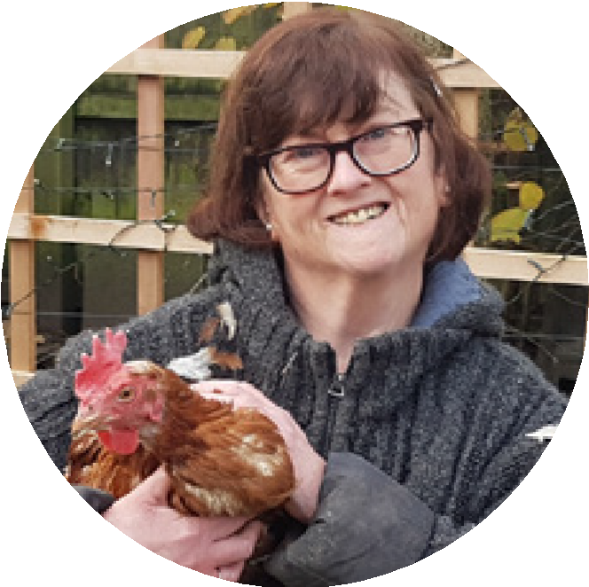

My Dream Home Guide | 13

04 Types of homes

Extra Care Tenancy

Extra care is usually suited to support older people and people with disabilities needing help and support to live independently.
It is also known as assisted living.
You may live in your own flat or share with others. There is onsite care
and support staff within the housing complex. There are usually shared leisure and activity areas, gardens, and dining rooms, where meals will be provided, at an additional cost.

My Questions

14 | My Dream Home Guide

Margaret’s story* 04

My name is Margaret, and I moved into my flat two years ago.

At first, I was nervous about leaving my house, but this has truly become my home. I have my own lovely one-bedroom flat with a kitchen and wet room, and I still feel independent but I know that help is always nearby.

The staff are kind and always there when I need them. I’ve made new friends through the activities like yoga, crafts, and film nights. I even joined
a gardening group! I love having meals in the restaurant and chatting with neighbours.

My family visits often, and they say I seem happier and more confident.
Living here has given me peace of mind, a sense of community, and the support I need to enjoy life again.



My Dream Home Guide | 15

04 Types of homes

Residential

Residential homes are often designed for people who need higher levels of support and provide assistance on a 24-hour basis.

You will have your bedroom and will share other spaces like the kitchen, lounge, dining room and activity areas. Normally meals and a support team will be included in the cost of the home.

My Questions

16 | My Dream Home Guide

David’s story* 04

My name is David, and I moved into a residential care home last year after a fall at home made
it clear I needed more support.

At first, I was unsure, but it’s been one of the best decisions I’ve made. I have my own room, which I’ve decorated with my favourite photos and books, and I share a cosy lounge and dining area with other people.

There’s always someone around to chat with, and the staff are kind and always there when I need help—day or night. I’ve joined a weekly art group, and we even have a sensory garden
where I enjoy spending time. I still feel independent, but I know I’m safe
and supported. I’ve made new friends, and we often watch films or play games together.

Living here has given me peace of mind and a real sense of belonging.



My Dream Home Guide | 17

04 Types of homes

Nursing home

This type of home is usually for older people with complex or significant health conditions, chronic illness and disabilities that would make it very hard to live independently, or with care at home.

This type of home is suitable if you need continuous health led care and supervision and assistance with daily living activities.

My Questions

18 | My Dream Home Guide

Wendy’s story* 04

My name is Wendy, and I’ve lived in a nursing home for people with learning disabilities for the past two years.

I have complex needs and need help with things like eating, washing, and getting around. The staff here are amazing—they know me well and always treat me with kindness and respect. I have my own room, which I’ve decorated with my favourite colours and soft toys.

Every day there are activities I can join, like music sessions, baking, and even gentle exercise classes. I especially
love the sensory room—it helps me relax when I feel overwhelmed. I also get to go on little trips with staff, like to the park. I feel safe here, and I’ve made friends with other residents.

The team supports me to be as independent as I can be, and I feel happy and cared for every day.



My Dream Home Guide | 19

Types of homes

Living in a private rented home

You can choose to live in a private rented home. These homes may be rented through a housing association or a private landlord. This can be paid for out of your wages or benefits.

You may be able to use Direct Payments to help with your care and support needs.

What is a Direct Payment?
Direct Payments are cash payments instead of services.
You can use Direct Payments to meet your needs as identified in your needs assessment. Direct Payments mean that you take responsibility for managing your own care arrangements on a day-to-day basis.

My Questions

20 | My Dream Home Guide

Stuart’s story 04

My name is Stuart and I love living in my own home.

I’ve faced many challenges in life, including losing my mother at a young age. Over the years, I’ve worked in various jobs—from carpentry and cleaning to working in a nursing home and now at Nando’s. When my father passed away in 2020, I was scared about how I’d manage on my own—paying rent, buying food, and handling bills. With support, I figured it out. I set up direct debits for my bills and now
I go shopping once a week with my best friend, Tina, who I talk to every day.
Living alone was frightening at first, but now I love it. I take care of myself, keep my home clean, and enjoy
the independence.

Being a representative for Cwm Taf People First has given me confidence and purpose. I’d recommend living alone—it’s helped me grow and feel proud of what I can do.



My Dream Home Guide | 21


My Dream Home

Where do I want to live?

22 | My Dream Home Guide





05

Who do I want to live with?

What do I want my room to be like?

What do I want to be near?

What help do I want to have?

My Dream Home Guide | 23


Having conversations

We understand it is a big decision thinking about getting your own home, and it’s a good idea to talk to people who you are important to you.

People you may be able to have helpful conversations with include your family, teachers, your GP, and others who have experience of moving into their own home.

Having these conversations may help you to discover a little bit more about what is best for you.

At this point you may also find it helpful to find people who may be able to help
you understand your rights. You may hear this person being called an advocate.

There is more information on advocacy on the next page.

My Questions

24 | My Dream Home Guide

Eleanor’s Story 06

My name is Eleanor and I am parent carer for my son.

My husband and I always hoped our son David, who is severely autistic and learning disabled, would move into supported living. After my husband died, I worried constantly about David’s future.

Talking to my friend and a social worker helped, and after waiting a while,
a place became available. The move was gradual with tea visits and overnight stays, and I stayed involved.

Having open conversations with professionals and friends made all the difference - it helped me feel heard and supported.
I’m now part of The Grapevine, a group for parent carers where we share advice, experiences, and support.
Seven years on, David is happy and more independent. I’m still a hands-on mum, advocating for him every day.

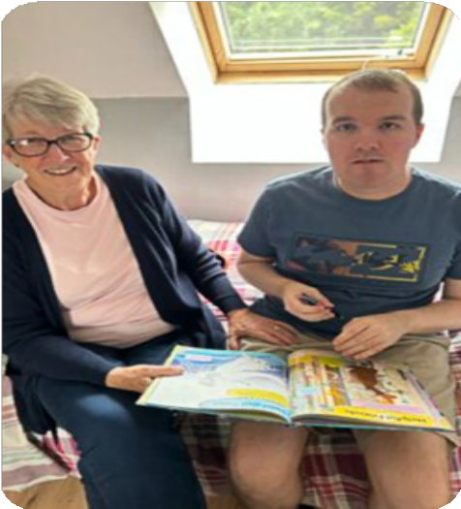

My Dream Home Guide | 25

Advocacy

An advocate is somebody who helps give you a voice. You are entitled to have an advocate.

This is somebody who listens to you and what you want because they have an independent role. How they support you depends on what you need, for example they can speak to your family or social worker if you need them to. Parents and carers can also have support from advocates.

There are different types of advocates:

Self-Advocacy groups
Often an organisation or a group who can help you speak up for yourself. Cwm Taf People First and People First Bridgend are examples of
Self-Advocacy groups.

Peer advocacy groups
When two people with a learning disability support each other through the journey.

Instructed advocacy
This is for people who can communicate their wishes and views, and the advocate will communicate this on your behalf.

Non instructed advocacy
If you are not able to share your wishes verbally, a non-instructed advocate will protect your rights and ensure you are treated fairly.

My Questions

26 | My Dream Home Guide

Example: Cwm Taf People First 07

Cwm Taf People First works across Rhondda Cynon Taf and Merthyr Tydfil to support people with learning disabilities to have more voice, choice, and control in their lives.

They help people speak up about what matters to them—whether it’s housing, health, education, or relationships.
If you’re thinking about your future—like where you want to live, work, or how to stay healthy—Cwm Taf People First can help you have the right conversations.
They work closely with local councils to make sure services are better and more inclusive.
They also offer advocacy, helping people understand their rights and make informed decisions. Whether it’s finding a job, making friends, or learning new skills, Cwm Taf People First is there to support you every step of
the way.

Talking to them could be a great way to explore what’s best for you.


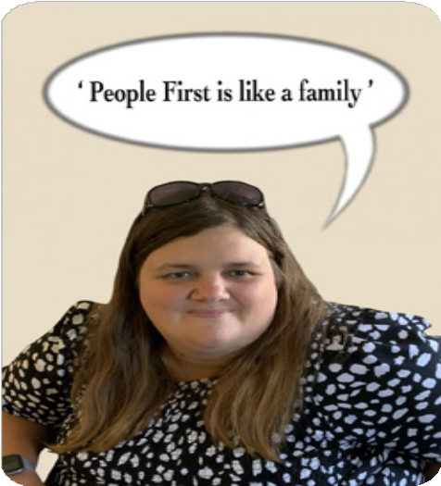

My Dream Home Guide | 27

Understanding Social Services

Social Services can support you to live independently. Social Workers can come out to visit you in your current home or a different place of your choice.

The Social Worker will want to know what is important to you. It is a good idea to have your ‘This Is Me’ (page 2) and ‘My Dream Home’ (page 22) filled in ready for this meeting, in addition to any other questions you have from this booklet. You can also ask any other questions you may have.

Social Services can be different in each area, so it’s important to contact the Social Services department in your local council.
Once you have arranged a meeting with the social worker, they will ask you to share things you need support with day-to-day.
This is everything to do with all areas of your life including your health and wellbeing. This can be things like washing, dressing, cooking, public transport, or being
with friends.

When you are ready to start the process, let social services know you are happy to move to the next step. They will complete a needs assessment with you. All your
needs will be recorded in your assessment, which will help you and the people who
are important to you plan and pick a home that is right for you.

You can find details in the directory on page 36.

My Questions

28 | My Dream Home Guide

Jane’s story* 08

Hello, I’m Jane
and I’m a social worker.

I first met Aaron and his mum, Sarah after they got in touch to talk about Aaron’s future. Aaron had been living at home all his life but was now ready to explore more independent living.
His mum was supportive but understandably anxious about what the next steps might look like.

Aaron had a needs assessment and
it was decided that he could get support from social services. We decided to make a plan together with his mum
that showed what he wants and what is important to him.
We started with a ‘What Matters’ conversation, where Aaron told me he wanted his own space but still needed some support with daily
tasks. His mum shared her hopes and concerns too, and together we looked at different housing options.

To make sure Aaron fully understood his choices, we brought in an independent advocate who helped explain things clearly. It was a real team effort and
a big step forward for Aaron.



My Dream Home Guide | 29

Arranging a visit

Finding the right home can take time.

If your social worker finds a home they think you will like, you can arrange a visit and meet the people who could be supporting you.

I would like to live on my own

If you decide you would like to live in your own flat, you can visit to see if it meets your needs. You can take whoever you choose with you when you visit. You can go back a few times to check the home is right for you.

If this home is what you are looking for a final decision will be made by you, people you trust and social services.

More details on this are on page 10.

My Questions

30 | My Dream Home Guide

09

I would like to live with others

If you’d prefer to live with other people, your social worker will arrange a visit. You may hear people calling this a ‘tea visit’. You can arrange to meet the people you may live with in a way that suits you. You can meet your new house mates in another place, like a coffee shop.
When you are ready, you will spend time with them in the home. This can be small visits, or you can stay overnight.

Visits will be managed around your and your new housemates’ needs and wishes. The most important thing is to make sure you are all happy to live together, and the home meets your needs.

You can take somebody with you, and you will also be able to meet the support team, who help everybody in the home to live as independently as possible.

My Questions

My Dream Home Guide | 31

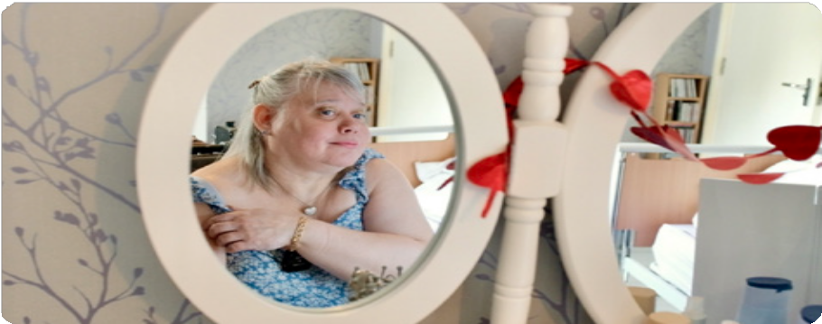
09

Overnight stay checklist

When you are ready, you can stay overnight.
For this there are a few things to consider taking with you:

Medication

Information how you’d like to be supported

Personal things that are special to you to help you feel comfortable and safe

This may include:
- Your favourite pillow or blanket
- Your favourite thing
- A picture of your family or friends
- Headphones

32 | My Dream Home Guide

Moving in 10

You may experience lots of different feelings when moving into your own home. This can be both an exciting and worrying time for you and people important to you.

At this stage, you will have had lots of conversations and visits to help you make your choice.

When you are ready to move in there will be lots of people to support you. Your moving experience will depend on your needs. For example, at first, you may still spend some time at your family home during the week.

People who are important to you can help you arrange the practical things, such as moving your personal items and making the home your own.

You will have support to feel safe,
and whatever home you have chosen, there will always be somebody available to answer your questions
or help you with any problems.

You can still see your family and friends as much as you choose, and your support
team will help you get settled in. Along with your family or carers, they can help you get familiar with the area, which may
be a new community for you.

We have included a Frequently Asked Questions section on page 34.

However, it is always a good idea to discuss anything you’d like to know with your social worker or support team.

Remember:
Finding the right home can take time and is different for everyone.
Talk to your social worker. They can help you understand the steps, tell you what to expect, and keep you updated on what’s happening.

My Questions

My Dream Home Guide | 33

11 Frequently asked questions

What is independent living?
Independent living is doing as much as you can for yourself in your home. Sometimes you may need support to help you. It is about having choice and control over your life.

What if my family do not want me to move out?
Refer to advocacy information on page 26.

Can I visit my family member and how involved can I be?
Yes, you can organise visits from your family and friends. It is your new home and family and friends are welcome.

How will my room be decorated?
You can choose to buy whatever you want for your room out of your own money.

How will health appointments work?
You can go to health appointments with people you trust, like family, friends or your support worker. You can also go alone if that is better for you.

Can I have some help to manage my bills?
There will be full support to help you manage your bills.

Do we have to accept the accommodation options presented?
No, but if they are not suitable for you, you will go back onto the waiting list.

Can I step back at any time?
Yes, you can change your mind at any time. It is your choice.

34 | My Dream Home Guide

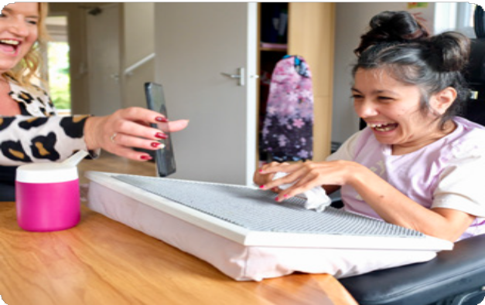
11

Questions for parents or carers

What if my family member has high care needs?
The staff would be trained to ensure your family member is well supported in their new home.

Can my family member come home for visits or overnight stays?
Yes, your family member can come home for visits and overnight stays whenever they choose.

What day time and evening activities will my family member be offered?
This will be outlined on their needs assessment and they can continue to do the things that are important to them.

How will transport work for my family member?
This will depend on their mobility needs. They may have a mobility car which they can continue to use with the support of staff. They may
continue to use public transport independently or with the support of staff.

Will my family member go on holidays?
Yes if they want to, but there is a cost involved for extra staff support. They can also still go on holiday with their families, if they’d like to.

How will the carers know my family members likes and dislikes?
Before your family member moves into their new home, their likes and dislikes will be recorded in a person centered plan and shared with the care staff.

My Dream Home Guide | 35

Directory

Support & Care Providers

Achieve Together
Address: Hirwaun
Phone: 03301 755 332

Fieldbay Supported Living
Address: Chestnut House, Tawe Business Village, Swansea
Enterprise Park, Swansea, SA7 9LA
Phone: 01792 771850

Gofal Cymru Care
Address: 2 Timothy Rees Close, Cardiff CF5 2RH
Phone: 029 2040 0657

Seren Support Services Ltd
Address: Ground Floor, Llewellyn House, Harbourside Business Park, Port Talbot, SA13 1SB
Phone: 01792 952640

Ty Eirin Care Home
Address: Parc Eirin, Thomastown, Tonyrefail, Porth, CF39 8EE Phone: 01443 675010

Ty Gwynno Care Home
Address: Hafod Lane, Hopkinstown, Pontypridd, CF37 2SD
Phone: 01443 408848

Ty Hafod Care Home
Address: Llantrisant Road,
Capel Llanilltern, Cardiff, CF5 6JR
Phone: 029 2089 2266

Ty Llwynderw
Address: Bridgend Road, Maesteg, CF34 0AJ
Phone: 01656 736613

Ty Porth Care Home
Address: Cemetery Road, Porth, CF39 0BH
Phone: 01443 508535

Housing & Community Support

Adferiad
Address: Unit B3, Lakeside Technology Park, Enterprise Park, Swansea, SA7 9FE Phone: 01792 816600

Arts Factory
Address: Trerhondda, The Strand, Ferndale, Rhondda Cynon Taff, CF43 4LY Phone: 01443 757954
Website: www.artsfactory.co.uk

Ategi
Address: Flynn House, Cardiff Rd, Pontypridd, CF37 5HP
Phone: 01443 484400

36 | My Dream Home Guide

Care & Repair
Address: 1st Floor, Trident Court, E Moors Rd, Cardiff, CF24 5TD Phone: 029 2010 7580

Cartrefi Coop – Bridgend Office
Address: Unit 2, Waterton Cross Business Park, South Road, Bridgend Industrial Estate, CF31 3UL
Phone: 01656 655606
Email: bridgend.enquiries@cartrefi.coop
Fax: 01656 662583

Cartrefi Coop – RCT Office
Address: Afon House, Aberrhondda Road, Porth, CF39 0BA
Phone: 01443 423109
Email: porth.enquiries@cartrefi.coop

DRIVE CYMRU – Head Office
Address: Unit 8, Cefn Coed,
Parc Nantgarw, Nantgarw, CF15 7QQ
Phone: 01443 845 260
Email: mail@drive-wales.org.uk

Innovate Trust
Address: 433 Cowbridge Road East, Cardiff, CF5 1JH
Phone: 029 2038 2151

Advocacy

Cwm Taf People First
Address: Maerdy Community Centre, Park Place, Maerdy, CF43 4DD Phone: 01443 757954
Email: enquiries@rctpeoplefirst.org.uk
Website: www.rctpeoplefirst.org/contact-us

Dewis Centre for Independent Living
Address: Suite 4 and 5, Nos 1 & 2 Melin Corrwg, Upper Boat, Pontypridd, CF37 5BE Phone: 01443 827930
Email: info@dewiscil.org.uk
Website: www.dewiscil.org.uk

People First Bridgend
Address: Apollo Business Village, Heol Persondy, Aberkenfig, Bridgend, CF32 9RF
Phone: 01656 668314
Email: info@peoplefirstbridgend.co.uk Website: www.peoplefirstbridgend.co.uk/ contact-us

My Dream Home Guide | 37

Directory

Parents and Carers’ Support

Bridgend Carers Centre
Address: Bethlehem Church Life Centre, Cefn Road, Cefn Cribwr, Bridgend, CF32 0AA
Phone: 01656 658479
Website: www.bridgendcarers.co.uk

The Grapevine (RCT)
Phone: Eleanor: 07732 830728 |
Kay: 07973 923066
Email: eleanorgrapevine@gmail.com

Local Authorities – Adult Services and Learning Disability Teams

Bridgend County Borough Council
Address: Civic Offices, Angel Street, Bridgend, CF31 4WB
Phone: 01656 643643
Email: aslearningdisabilityteamduty@ bridgend.gov.uk

Merthyr Tydfil County Borough Council
Address: Civic Centre, Castle Street, Merthyr Tydfil, CF47 8AN
Phone: 01685 725000
Email: adult.intakeservice@merthyr.gov.uk

Rhondda Cynon Taf County Borough Council
Address: Bronwydd House, Porth, CF39 9DL
Phone: 01443 425003
Email: socialservices@rctcbc.gov.uk

Phone: 01443 743665
Email: socialworkemergencydutyteam@ rctcbc.gov.uk

Health – Cwm Taf Morgannwg Learning Disability Services

Cwm Taf Morgannwg University Health Board – Learning Disability Teams
Address: Ynysmeurig House, Unit 3, Navigation Park, Mountain Ash, CF45 4SN Phone: 01443 744800
Website: www.ctmuhb.nhs.wales

Community Learning Disability Teams (CLDTs):
- RCT North CLDT: 01685 351279
- RCT South CLDT: 01443 220418
- Bridgend CLDT: 01656 815353
- Prince Charles Hospital: 01685 721721
- Royal Glamorgan Hospital: 01443 443443
- Princess of Wales Hospital: 01656 752752

38 | My Dream Home Guide

Housing Associations in RCT, Bridgend, and Merthyr

Aelwyd Housing Association
Address: Plas Carmel Graigwen Road, Pontypridd CF37 2TX
Phone: 029 2048 1203
Website: www.aelwyd.co.uk

Beacon Cymru
Address: Ty Gwyn Newydd, 9 Compton Road, Tonypandy, CF40 1BE
Phone: 01443 424200
Website: www.beacon.cymru

Cadarn Housing Group
Phone: 0303 040 1998
Website: www.cadarn.co.uk

Cynon Taf Community Housing
Address: Navigation Park, Abercynon, Mountain Ash, CF45 4SN
Phone: 0345 260 2633
Website: www.cynon-taf.org.uk

First Choice
Address: Avon House, 19 Stanwell Road, Penarth, Vale of Glamorgan, CF64 2EZ Phone: 029 2070 3758
Website: www.fcha.org.uk

Hafod
Address: St Hilary Court, Copthorne Way, Cardiff, CF5 6ES
Phone: 0800 024 8968
Website: www.hafod.org.uk

Merthyr Tydfil Housing Association
Address: 13 Lower High Street, Merthyr Tydfil, CF47 8EB
Phone: 01685 352800
Website: www.mtha.org.uk

Merthyr Valleys Homes
Address: Ty Brychan, 22 Lansbury Road, Gellideg, Merthyr Tydfil, CF48 1HA Phone: 01685 727772
Website: www.mvhomes.org.uk

Pobl
Address: Exchange House, High Street, Newport, NP20 1AA
Phone: 01633 212 375
Website: www.poblgroup.co.uk

Taff Housing
Phone: 029 2025 9100
Website: www.taffhousing.org.uk

My Dream Home Guide | 39

Directory

Trivallis
Address: Ty Pennant, Catherine Street, Pontypridd, CF37 2TB
Phone: 0300 003 0888
Website: www.trivallis.co.uk

United Welsh
Address: Y Borth, 13 Beddau Way, Caerphilly, CF83 2AX
Phone: 0330 1596 080
Website: www.unitedwelsh.com

Valleys to Coast
Address: Tremains Business Park, Tremains Road, Bridgend, CF31 1TZ Phone: 0300 1232 100
Website: www.v2c.org.uk

Wales & West Housing
Address: Archway House, 77 Parc Tŷ Glas, Llanishen, Cardiff, CF14 5DU
Phone: 0800 052 2526
Website: www.wwha.co.uk/en

National Organisations

Mencap
Website: www.mencap.org.uk

Learning Disability Wales
Website: www.ldw.org.uk

National Autistic Society
Website: www.autism.org.uk

Carers Wales
Website: www.carersuk.org/wales

40 | My Dream Home Guide

My Notes

My Dream Home Guide | 41




Your Feedback
Please let us know your thoughts on this booklet by filling
in this short survey via the QR code at the bottom of the page. You can also contact the person who provided the booklet to you.

Name

Job title

Organisation

Email address

Phone number

We will use your feedback to make this booklet better. Thank you for your time. We hope you enjoy searching for your new home.

